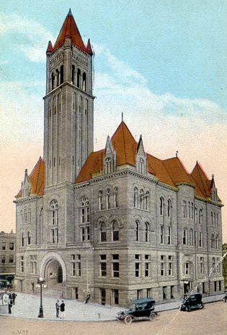
Courthouse Facilities
Improvement Authority

Agenda
February 22, 2017
10:00 a.m. – Conference Call

- Roll Call/Establish Quorum/Approval of Minutes/Introduction of Guests

- Reports and Considerations

  - Welcome New Board Members
  - Financial Update
  - Grant Update
  - Executive Director’s Report

- Old Business

- New Business
- Designation of Board member as P-Card Reviewer
- Pcard monthly expenditures approval
- Pcard Internal Controls Policy update
- Annual review of Pcard purchases
- Time Extension Requests: 13th cycle grants-Brooke (March 30, 2017)

- Executive Session
- Good of the Order

- Next Meeting

Agenda and Order of the Agenda are Subject to Change
For Updated Agenda Information, please call 304-558-5435

Executive Director’s Report

- All new 14th cycle grant contracts with original signatures have been received except Webster.
- Zero bids received for gutter project. Going to re-bid.
- Purchasing Training last Wed. Director must complete 10 hours of training per year with the Purchasing Division.
- Booth in Vendor Hall at the WVACo conference on March 5 and 6
- Booth in Vendor Hall at the Construction and Contractor’s Expo at the Civic Center on March 22 and 23. Also will be teaching a class on Courthouse Maintenance and Project Highlights on the 22nd at 11:00 a.m.
- SB 35 – Senator Stollings once again introduced to bill to allow us to fund annexes when we already fund annexes.

