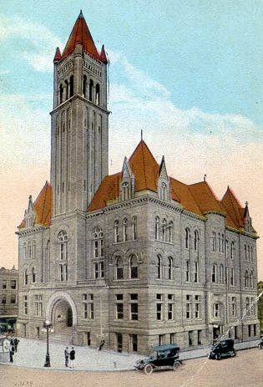
Courthouse Facilities
Improvement Authority

Agenda
April 5, 2016
10:00 a.m. – Conference Call

- Roll Call/Establish Quorum/Approval of Minutes/Introduction of Guests

- Reports and Considerations

  - Financial Update
  - Grant Update
  - Executive Director’s Report

- Old Business

- New Business
- Pcard approval
- Time Extension Requests: Wirt (4/30), Wayne (4/30)
- Scope Expansion: Randolph (additional windows); Raleigh; Wood

- Executive Session
- Good of the Order

- Next Meeting

Agenda and Order of the Agenda are Subject to Change
For Updated Agenda Information, please call 304-558-5435

Executive Director’s Report

- OASIS update – new grants entered, payroll implementation underway with a go-live of May 14
- Legislative Update – digital tax map sales passed, concealed carry permit fees will likely decline, definition bill died in House
- Teaming with WVACo for regional meetings. June 9th in Morgantown and June 10th in Logan. Will do two other, more detailed grant trainings with one of those being in Logan, as well, and another location in the north.
- 40 participants attended class during Construction Expo. Used new presentation board for 1st time.
- Annual State Auditor’s Conference has been cancelled due to budget shortfall.
- No Budget to approve yet.
- Brick repointing project update.
- Investing $ idea.

